Square and Cube Numbers - Questions

Key Stage 2: 2003 Paper A
1.
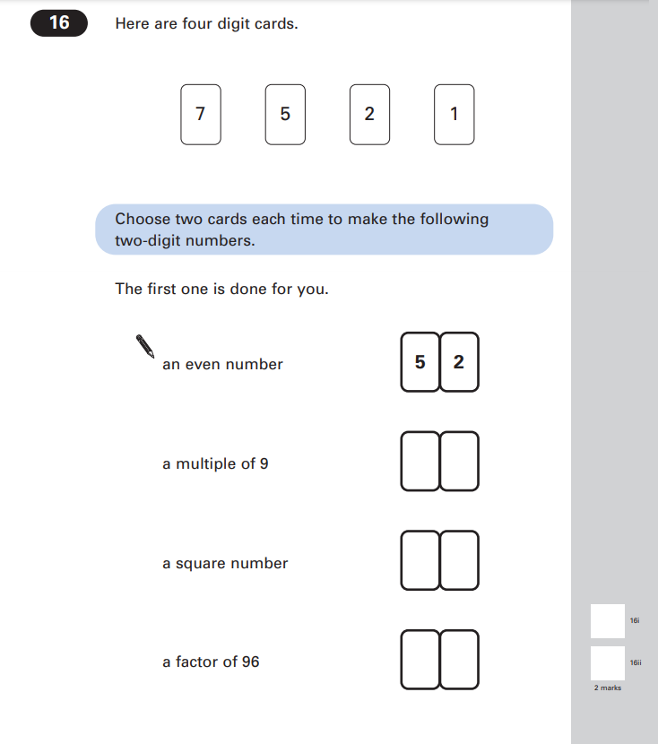
Key Stage 2: 2004 Paper A
1.
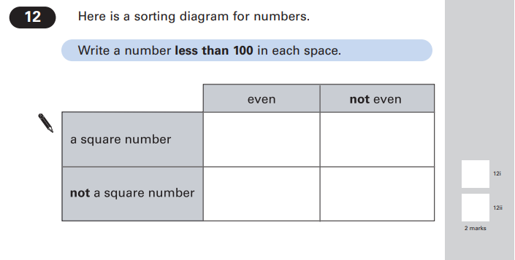
Key Stage 2: 2005 Paper A
1.
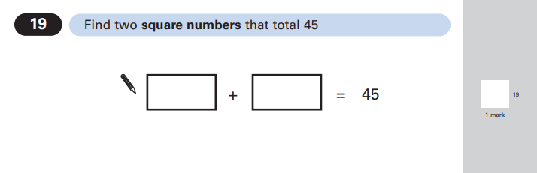

Key Stage 2: 2009 Paper B
1.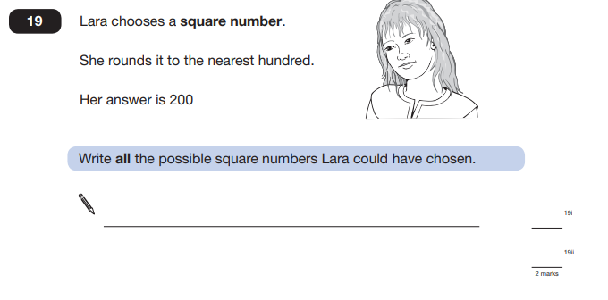Key Stage 2: 2012 Paper B L6
1.
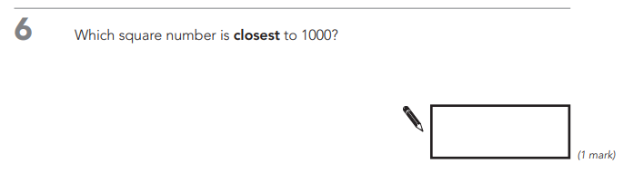Key Stage 2: 2013 Paper B
1.
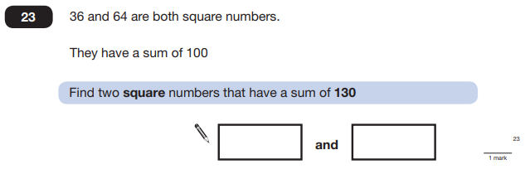
Key Stage 2: 2016 Paper 1 Arithmetic - Sample
1.
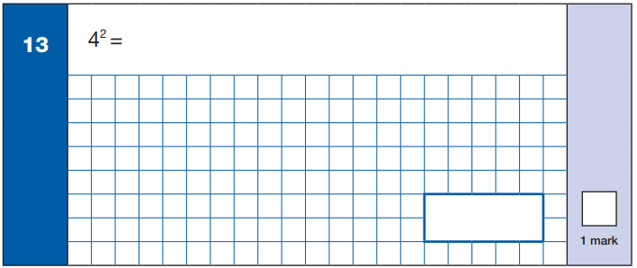
Key Stage 2: 2016 Paper 1 Arithmetic
1.
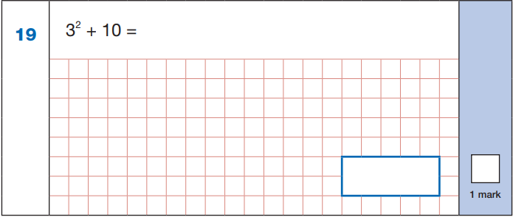

Key Stage 2: 2018 Paper 1 Arithmetic
1.
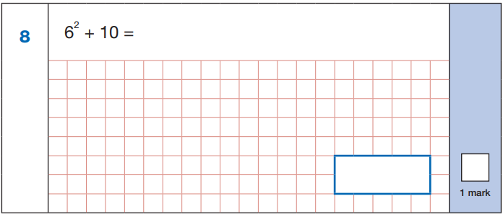
Key Stage 2: 2019 Paper 1 Arithmetic
1.
